**Part 1 (MS Word)**  
🡺your dictionary of token/string characters, one entry per line.

* = the

} = came

( = wa

? = up

! = out

] = ed

^ = itsy

@ = &

& = spider

% = ain

🡺rhyme with the token substitutions, i.e. the compressed text

*^b^&crawl]?*(tersp!. down}*r%@(sh]*&!.

!}*sun@dri]?all*r%@*^b^&went?*sp!ag%.

🡺 how many characters are in the dictionary + compressed text and what is it as percentage of the original’s 187?

76 characters in total and (76/187 * 100% =) 40.6% as percentage of the original’s

**Part 1: Compression (40 points)using Notepad++**

🡺your dictionary of token/string characters, one entry per line.

* = the

} = came

( = wa

? = up

! = out

] = ed

^ = itsy

@ = &

& = spider

% = ain

🡺rhyme with the token substitutions, i.e. the compressed text

*^b^&crawl]?*(tersp!. down}*r%@(sh]*&!.

!}*sun@dri]?all*r%@*^b^&went?*sp!ag%.

🡺 how many characters are in the dictionary + compressed text and what is it as percentage of the original’s 187?

76 characters in total and (76/187 * 100% =) 40.6% as percentage of the original’s

**Part 2 (Word):**

Paste the image of the Windows Explorer .zip file information here…

Use the Snipping Tool ( + “snip”) to copy only the information seen above.

**🡺**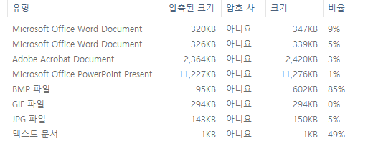

What do the compression ratio percentages tell you about the contents of the different kinds of files?Were some of the files already compressed in their original format before zipping tried to compress them further? Which files do you think were already compressed? **(10 points)**🡺 The higher the compression ratio percentage is, the greater size the files would get compressed after zipping. A few files indicated high compression percentage, but only the .gif file was already compressed in their original format before zipping tried to compress it further. (macaw.gif file in this case).

The files with high Ratios were compressed the most. Which files were they? Whywere they compressed the most?**(10 points)**  
🡺 ‘macaw.bmp’ (.bmp file) and ‘Quotes for compression.txt’ (.txt file) indicated high compression ratio percentages (85% and 49% respectively).

**Part 2 (Notepad):**

Paste the image of the Windows Explorer .zip file information here…

Use the Snipping Tool ( + “snip”) to copy only the information seen above.

**🡺**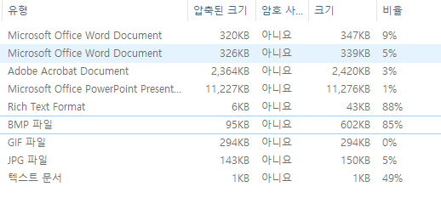

What do the compression ratio percentages tell you about the contents of the different kinds of files?Were some of the files already compressed in their original format before zipping tried to compress them further? Which files do you think were already compressed? **(10 points)**🡺 The higher the compression ratio percentage is, the greater size the files would get compressed after zipping. A few files indicated high compression percentage, but only the .gif file was already compressed in their original format before zipping tried to compress it further. (macaw.gif file in this case).

The files with high Ratios were compressed the most. Which files were they? Whywere they compressed the most?**(10 points)**  
🡺 ‘macaw.bmp’ (.bmp file),‘Quotes for compression.txt’ (.txt file), and Rich Text Format word file indicated high compression ratio percentages (85%, 49%, and 88% respectively).

**Part 3: Backup**

🡺 paste a screen shot of your backup results. (Alt-PrtScn or use the Snipping Tool) **(10 points)**

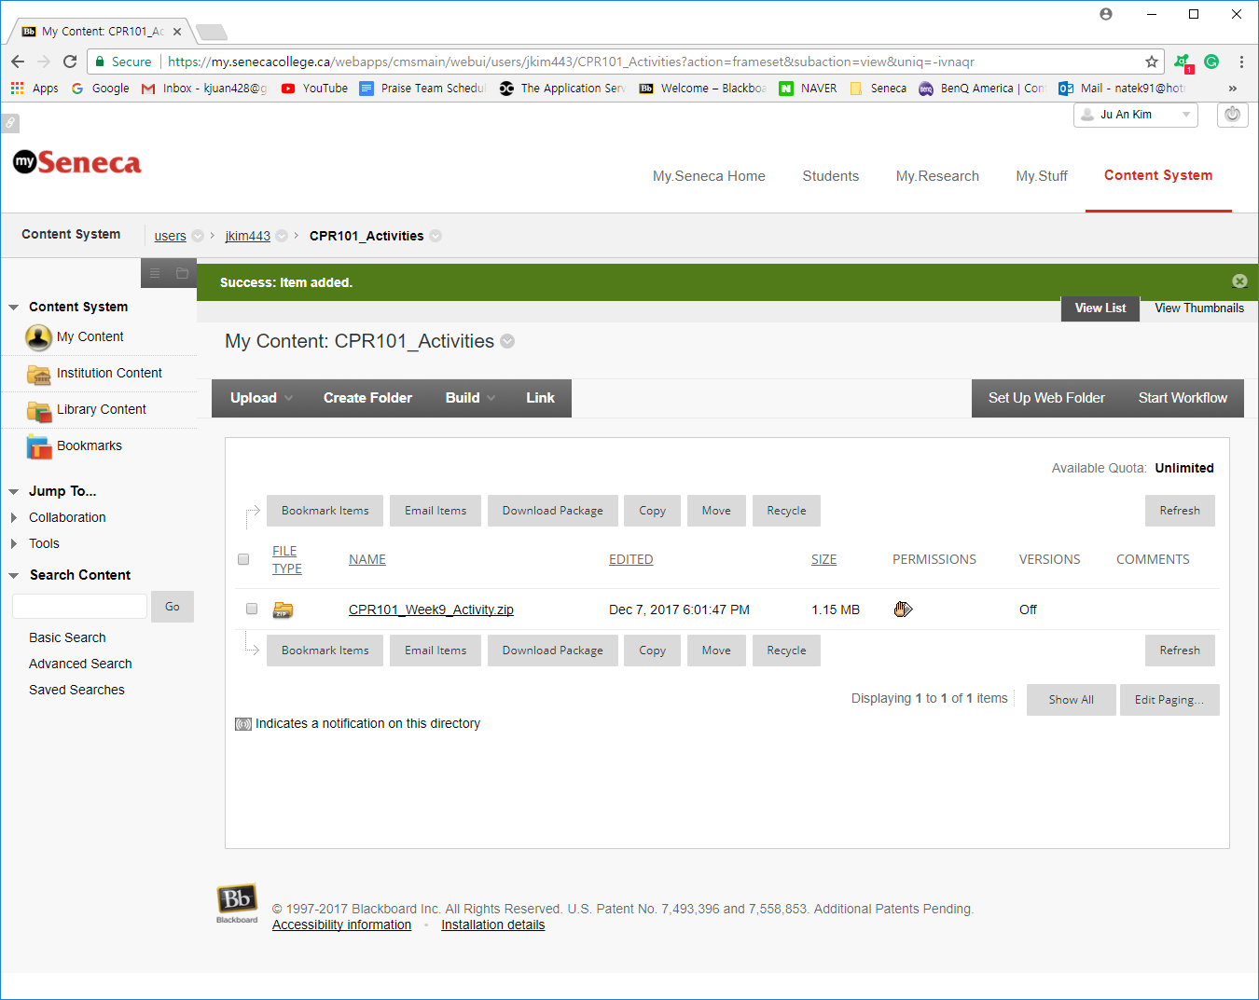

**Imagine your laptopjust went up in smoke/melted down/destroyed itself** after you completed a great many hours of work today and yesterday. What is (or what should have been) your backup & restore strategy? How does your strategy address the 3 characteristics of a real backup? How does your strategy fulfill the 3-2-1 backup check? Replacing a machine is more than just restoring your lost data files. What about the Operating System and the applications which process those files? How long would this all take…and what if you a had a big assignment due tomorrow?**(30points)**🡺 There are a plenty of methods/devices to use for my backup & stategy.

1. USB: I would frequently save or overwrite any simple documents, application data and media files in USB.
2. Internet/Online Backup service (Cloud, DropBox, or Google storage): I would probably not use this method, but as long as you have internet, I can always automate my backup and store it in online database. (Inherent flaws: Vulnerable to privacy invasion and hacking).
3. Network-attached storage device: For saving multimedia files consisting of photos and videos that rarely change.
4. System recovery and backup: If my HDD crashes and has to be replaced, Windows won’t be able to retrieve my lost data, and I would have to reboot and re-install the OS including drivers from the scratch. But System recovery function in the OS stores full-system as a whole and I would be able to restore all my data.
5. External Hard drive: A physical and portable HDD where I can almost store the whole system/data as a whole as well and keep it in my shelf like a PC passport.

These strategies cover the three methods that we could use for backup; local, external, and network. Some methods are a real-time backup/continuous back up where the system automatically saves a copy of every change made to the specified data, and some methods are not real time; not frequent, but we can store a big chunk of important system data as well.

These strategies also met all the requirements in 3-2-1 backup checklist.

3: 1 network (online service or clouding), 1 local backup (System recovery feature), and 1 remote backup (external HDD).

2: 2 different formats or platforms as well; HDD passport (physical) and cloud (online).

1: off-site backup: I sue Cloud storage, dropbox, and Google storage; are accessible as long as the internet lives. I also sometimes carry my external HDD passport for transferring a big chunk of multimedia files to other computer from home to school/workplace.